[Math Racing](https://play.google.com/store/apps/details?id=com.wilddevilstudios.mathracing&hl=en)

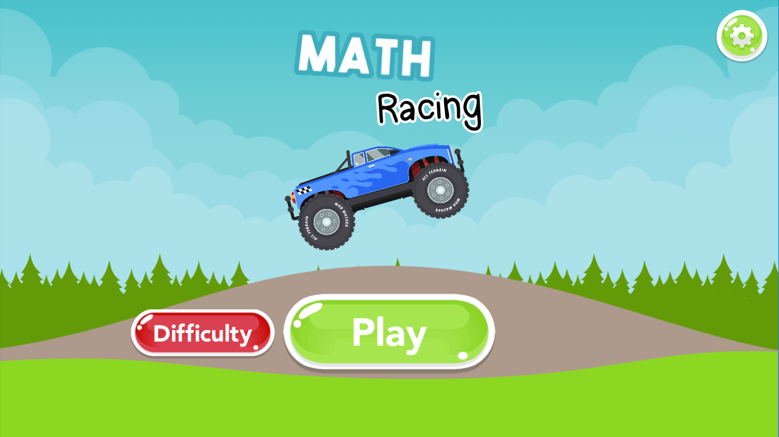

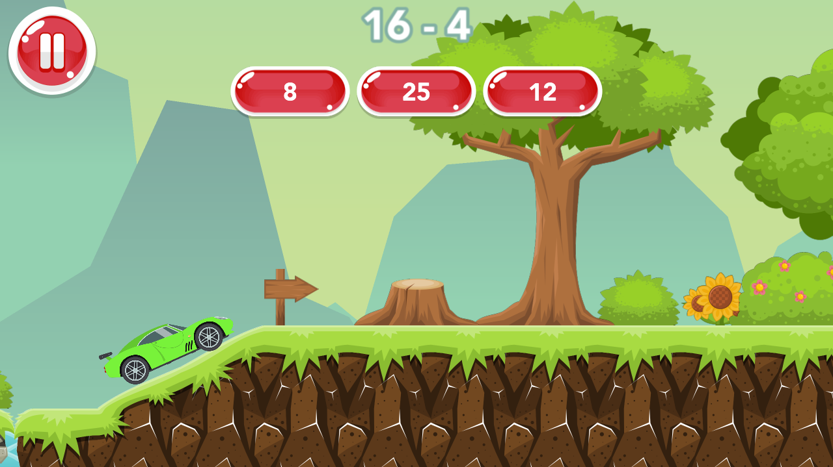

* Interactive multiple-choice questions which is the same approach that we are using to create our game
* The buttons are consistent and are quite large
* Colours are saturated but not overpowering

[Racing Games for Toddlers](https://play.google.com/store/apps/details?id=by.alfasoft.CleverKidCars)

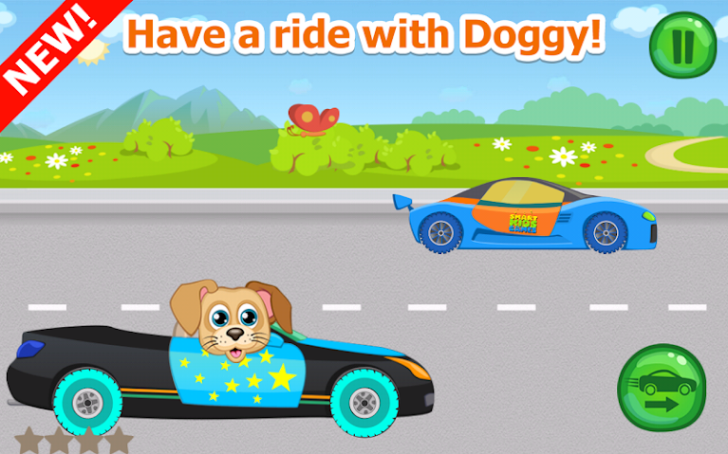

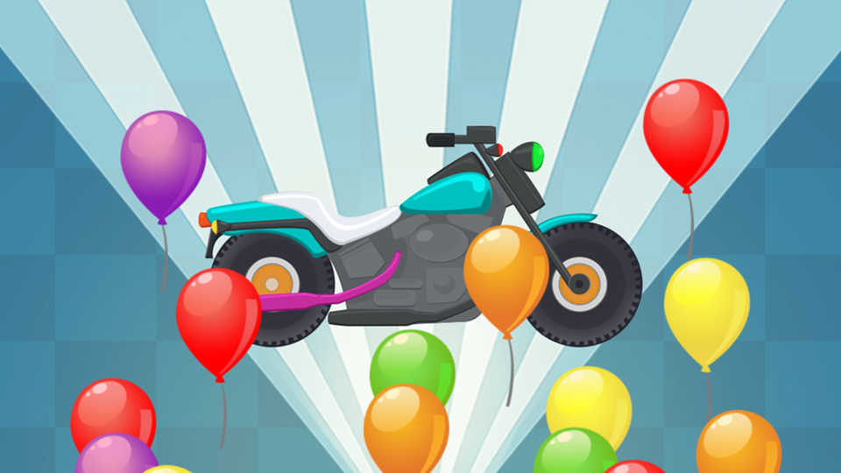

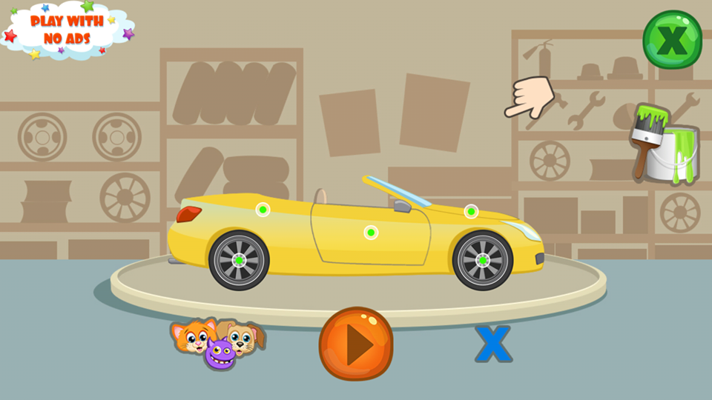

* UI itself is quite simple, but the gameplay is neither particularly intuitive nor interactive
  + Player hold the button in the bottom right corner (however, I couldn’t tell if this was correct as it made the car wheels appear to spark)
  + Player comes across obstacles equivalent to number of stars (2 stars means 2 obstacles), and tap once to remove them before continuing to hold the bottom right button
* Particularly liked the visual feedback when obtained a reward such as a new car
* Players were presented with an option to choose their racer and their vehicle before proceeding to the track

[Kids Car Racing Game – Beepzz](https://play.google.com/store/apps/details?id=com.iabuzz.apk.BEEPZZ)

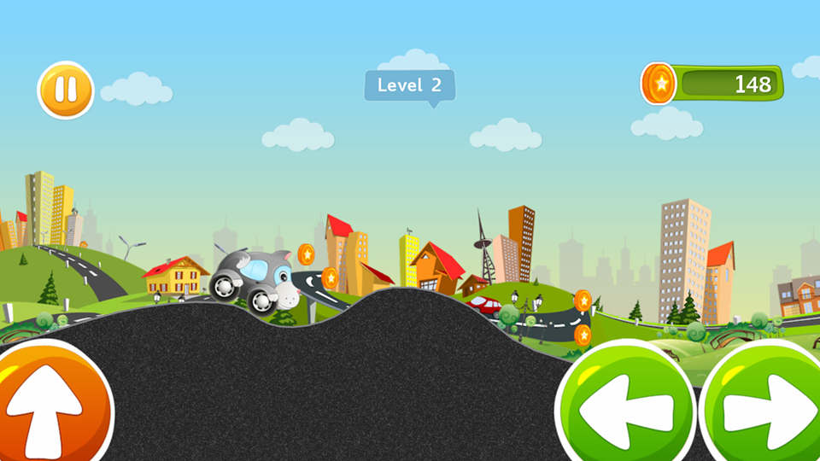

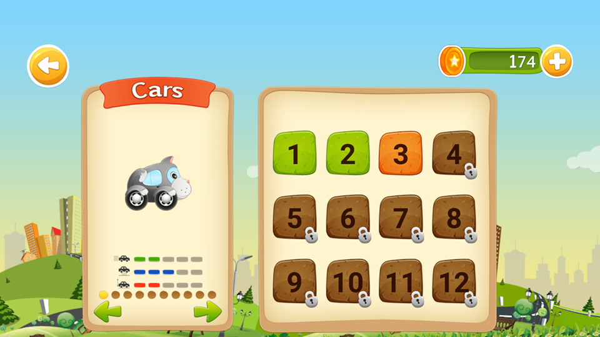

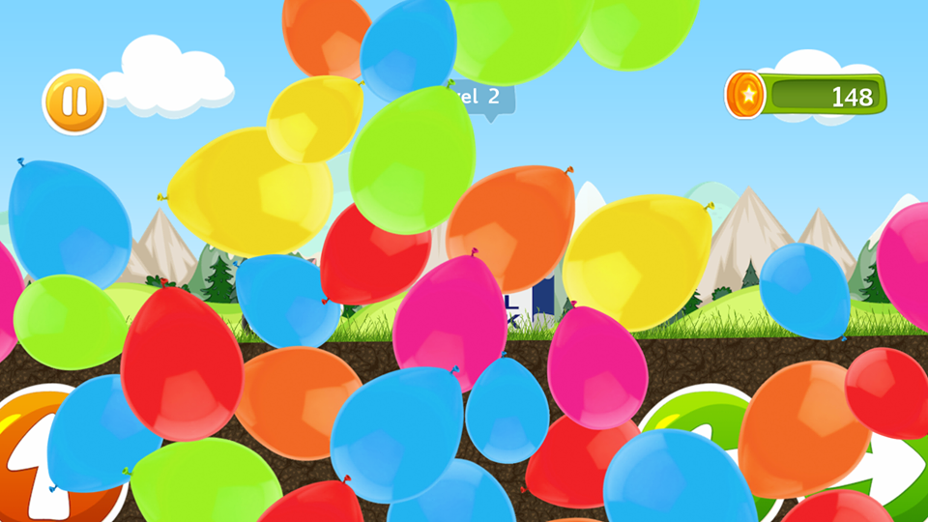

* Large buttons for the core interaction, intuitive gameplay
  + I knew instantly that I had to use the button to collect coins and get to the end of the track
* Took me a while to figure out how to change my vehicle and unlock new options as the menu itself is quite discreet
* Collect coins to unlock new cars and tracks
* Cars themselves are based on animals and each have different stats
* Exaggerated visual feedback at the end of track, balloons rise from the bottom of the screen
* The milestone at the end of the track changes depending on the vehicle you have selected (if using dalmatian car, then the end goal is a bone is a dog bowl)

Based on our demographic, I spent a lot of time playing games catered towards that age group, including racing games that were geared towards allowing children to practice their maths. I also played some popular mobile games: Fruit Ninja, Angry Birds and Plants vs Zombies. Other games that I played during this research task are as follows:

* [Math Racing](https://play.google.com/store/apps/details?id=com.anucom.Math_Racing), AnuCom Games
* [Kids Car: Snow Racing](https://play.google.com/store/apps/details?id=com.SneakyBox.KidCarReacingGame), Happy Kids Lab
* [Bike Race Free](https://play.google.com/store/apps/details?id=com.topfreegames.bikeracefreeworld), Top Free Games.
* [Kids Car: Offroad Racing](https://play.google.com/store/apps/details?id=com.sneakybox.kidscaroffroadracing), Happy Kids Lab
* [Farm Race – Kids Racing Game](https://play.google.com/store/apps/details?id=com.CoolAwesomeFun.FarmRace.Kids.Racing), Cool Awesome Fun
* [Kids Racing Islands](https://play.google.com/store/apps/details?id=com.azulmultimedia.kidsracing), Azul Multimedia
* [Kids Racing](https://play.google.com/store/apps/details?id=com.CoolAwesomeFun.KidsRacing), Cool Awesome Fun
* [Kids – Racing Games](https://play.google.com/store/apps/details?id=com.YovoGames.KidsRacing2), Games from YoVo Games!
* Dr Panda Town: Pet World
* Cutie Cubies

From researching these games, I noted that

* Play button is generally large and distinctive
* Other buttons are much smaller
  + High scores and options are most common
* Menu and UI are simple and clean, provide some sort of visual feedback to the player
* It’s important to use visual hierarchy
* Consistency is key
* A lot of the games aimed at children between the ages of 6 and 9 use saturated and vibrant colours
* Small rewards and achievements are often exaggerated with visual feedback such as particle effects and animations